Description of the Home depot applications:

:
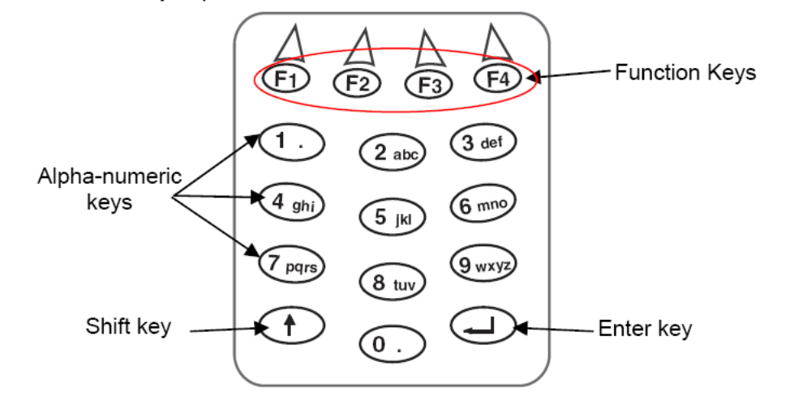
Keys descriptions
F1 | Price Inquiry.  or  Sync | It is used for determine the price of an article. It send a to the POS.  If this key is pressed while the main trigger is pressed it assume the function of the sync.
F2 | Shift | It is used to switch from Number to Alphanumeric symbols. The behaviors is changed for Home Depot, Shift has effect only for the next key pressed, that it return to NUMERIC. because in this application alphanumeric symbols are normally unused.
F3 | Back Space | Used to delete the last character entered.
F4 | ESC | This key send a message directly to the POS. In Current applications is used to Abort some Transactions.
1 to 9 |  | Numeric Keys ( Alphabetic when shift is pressed).
↑ | Enter quantity | This Key is no more a Shift but is the key used to enter quantity. It behaves in this way:  User has to enter a quantity on the screen. Quantity can be 8 character long, and must be numbers or one decimal points. Everything else is refused and an error Message appears on the display.
↵ | Enter | When enter is pressed the collected data is sent to the POS.

Transmission formatting:

When a label is read by the scanner it is formatted in this way: | <Label>%P1.2%V
When a label or a generic value is entered by the keyboard it is formatted in this way: | <Label>%P1.2%V%K
Code Quantity: A Code could be sent with a quantity information.  To do that this is the sequence:  Enter a number with the keyboard that has to be a quantity.  Press Up Arrow: The number is confirmed as a Quantity.  Than enter the code ( by a label or by keyboard ) the message is so formatted: | <Label>%P<Qty>%Q1.2%V%K  or  <Label>%P<Qty>%Q1.2%V
A void message is so formatted : | %P1.2%V%O
ESC ( mapped on F4 ): When pressed sends this message: | %P1.2%V%E
Inq (Inquiring mapped on F1 ): When pressed sends this message: | %P1.2%V%I
Synk: ( mapped on Shift when trigger pressed ): When pressed sends this message: | %P1.2%V%S

Receptions messages and Display formatting:

Everything is received by the POS is showed on the display whit some exceptions described after. Because POS applications is previously written for a different scanner with 20 characters X 2Lines display size, Powerscan has to split message in two lines and introduce a CR by itself.
When Message start with ‘%’ or ‘@’ This character are deleted from the showed string.
SS4024.TXT collects some example of strings that have to be correctly shown in the 16x4 display size of the Powerscan.

Message on the screen is maintained until another messages has to be show. Screen doesn’t return to the originally message by itself. This is obtained by disabling initial screen timeout (IRQ00 by Default).
QTY = 1 is not more the initial screen. This message appears only when Up-Arrows is pressed.
What is written on the display because POS Messages or because self Messages of scanner can not be deleted with back Space key.
The following Messages are managed as exceptions:

Message | Number of beeps
"Enter Total Feet" | 2
"Enter Square Feet" | 2
"Enter Square Yards" | 2
"Assembled? 1Yes,9No" | 2
"Warranty Info - OK" | 4
"Charge ECO Fee - OK" | 4
"Enter DOB: MMDDYYYY" | 2
"Enter Item Quantity" | 2
"Please See Register" | 4
"Price Inquiry" | 2
"OK Pressed" | 1
"Invalid UPC " | 1

Right now exceptions consist mainly in the sound sequences used to notify them ( see table before).
1 single BEEP is executed for all the other messages.
“OK pressed” is normally converted in a completely different message. It is done to try to give a better information to the cashier in place of the POS applications. When “OK Pressed” is received it is converted in something related to the last exceptions received.
“Ok Pressed” is transformed in “Please See Register” if the previous Exceptions was “Warranty…”
“Ok Pressed” is manteined as it is if the previous Exceptions was “Charge ECO…”
“Ok Pressed” is Converted in "Assembled? 1Yes,9No" if “Assembled..” and “Register..” is previously received in this sequence.
“Ok Pressed” Is converted in the previous exceptions message for all the other case.
“Invalid UPC” is converted in “Invalid Quantity” if previous exceptions is “Enter Item Quantity”

Messages generated by the Scanner itself:

“Ready” | Showed at the startup.
“QTY = <xx> | when up Arrow is pressed.
“Please Wait…. ” | Is showed while 2way transmission is in Progress in place of the Message Echo. It is replaced by the message received in answer from the POS.
“Invalid Quantity” | Is showed after a Up-Arrow pressed if the quantity is not valid.
“Please See Register” | When a Communication timeout occurs

This is some sequence and screen example:

Code Quantity
1) Starting from the first screen press 1 and 2:|
Ready
12¦
Inq Shft ← ESC

2) Than press up arrow
QTY =12
¦
Inq Shft ← ESC
3) And Scan a code 456789. The following message is sent: 456789%P12%Q1.2%V
or
3bis) Enter the barcode manually:
QTY =12
456789
Inq Shft ← ESC
The following message is sent to POS: 456789%P12%Q1.2%V%K

And the following message appear while POS is preparing an answer.
Please Wait...

Empty message means that enter is pressed without any characters entered before.

